114306062 劉芊禕 資管一乙

Prompt : a watercolor painting of a quiet street in a small town or village. The scene is bathed in sunlight, casting soft shadows across the narrow path. On either side of the street are traditional wooden houses with tiled roofs and stone walls.

Two large cherry blossom trees in full bloom, their pink petals glowing against the blue sky, dominate the scene. Behind the houses, a lush green mountain rises, adding depth to the composition. Power lines and a street lamp extend across the street, giving the painting a sense of everyday life.

The overall mood is peaceful, nostalgic, and filled with the warmth of spring.

一張含有 戶外, 樹狀, 天空, 植物 的圖片

AI 產生的內容可能不正確。

Prompt : Without changing the original picture, add a picture of a family of three, including a father, a mother, and a child, walking hand in hand on the road

Result :

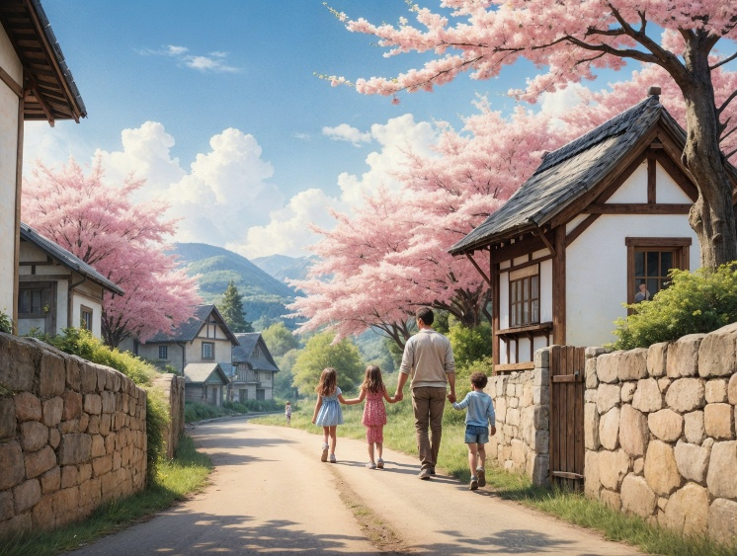

Visual Prompt :

v

Result: